Q.1 seal and sealing of haddpan

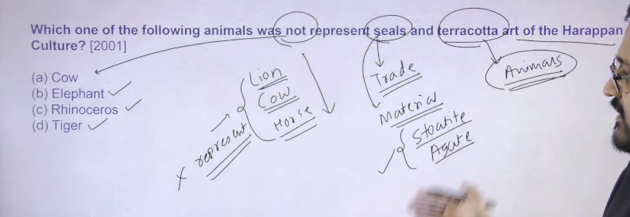

Ans: A

Seals signify trade and seal used on trade cartons they signify the large scale of trade of haddpan

Material is used on seal is steatite and agate there are two type of stoen which is used making of seal apart from those different type of material like gold , copper , bronze different type of material has also been used in order to make the seal

Terracotta figurines of different kind of animal has been discovered

There are two type of animal which are not present on haddapan seal Cow, Lion Horse these three animal does not represent on haddapan art different tpe of animal has been depicted but these animal has not like deere is there buffalo is there rhino is there elephant is there so thes type of different kind of animal has been depicted there

Then these aminal are something that is not represent on haddpan seal as well as art also

This is the basic information regarding seals and sealing of haddpan

2

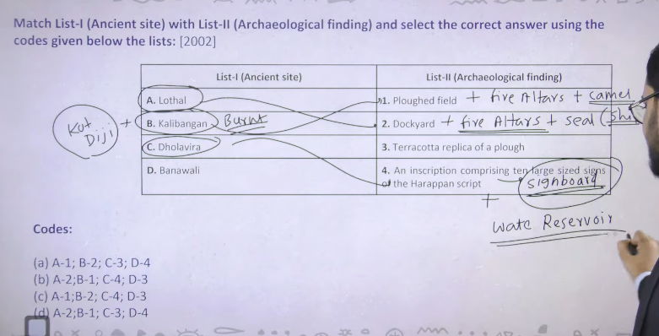

3

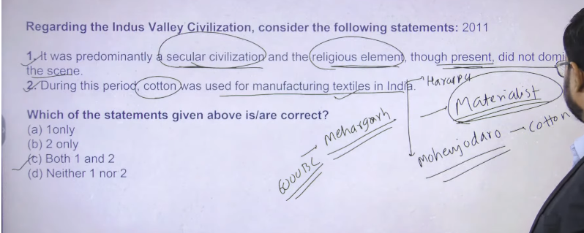

4

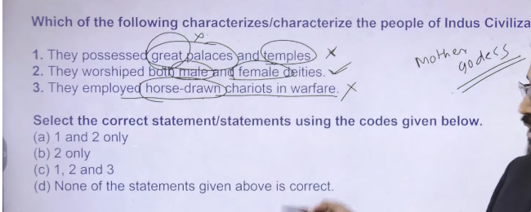

5

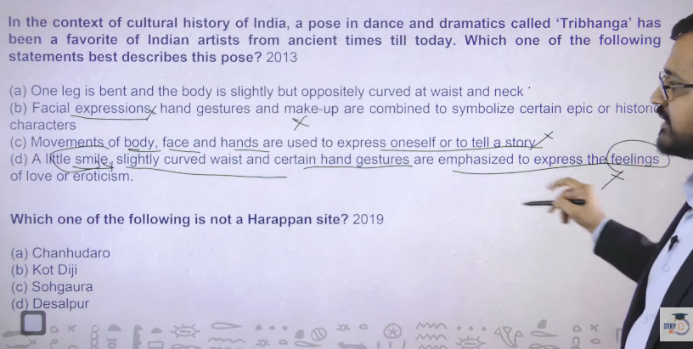

6

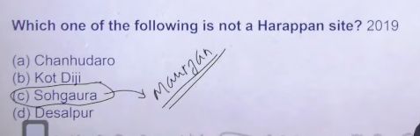

7

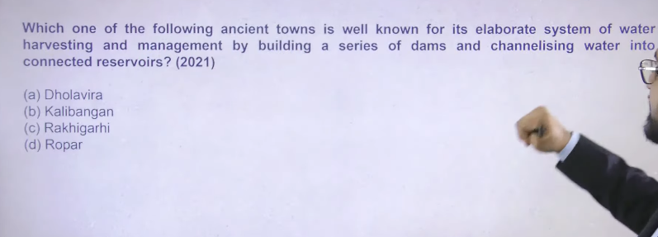

8

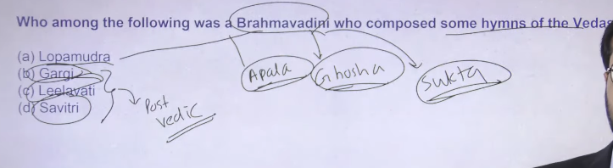

9

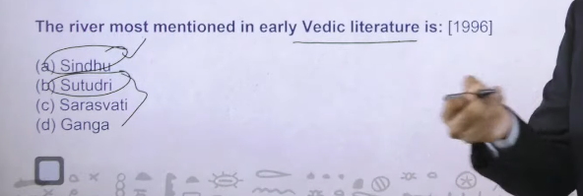

10

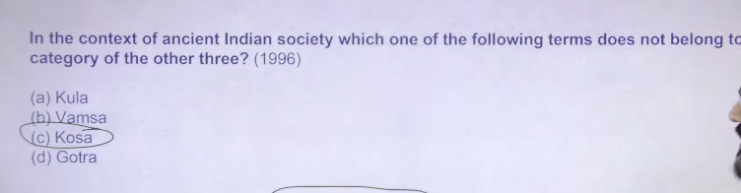

11

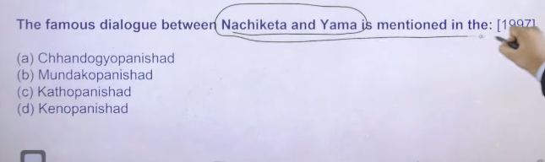

12

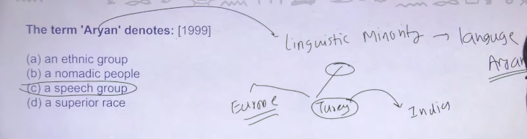

13

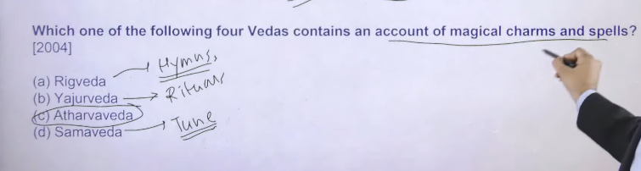

14

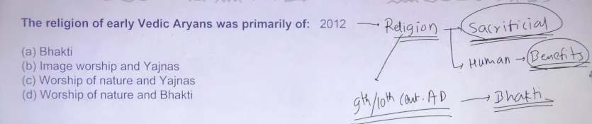

15

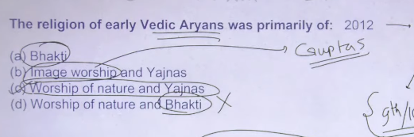

16

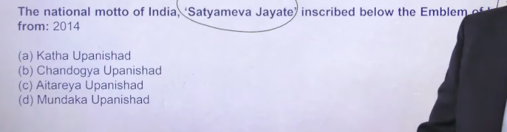

17

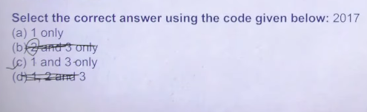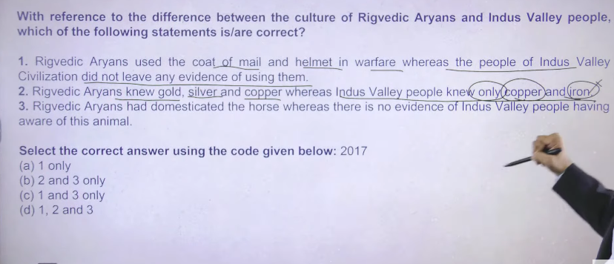

12

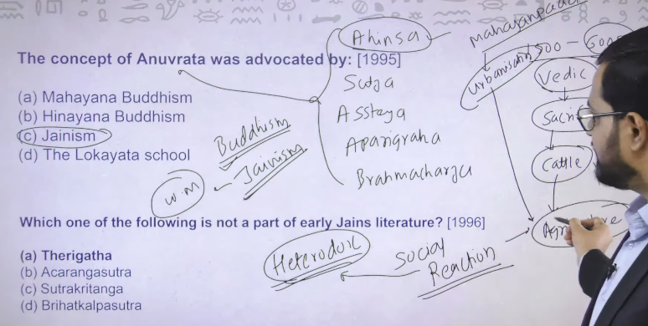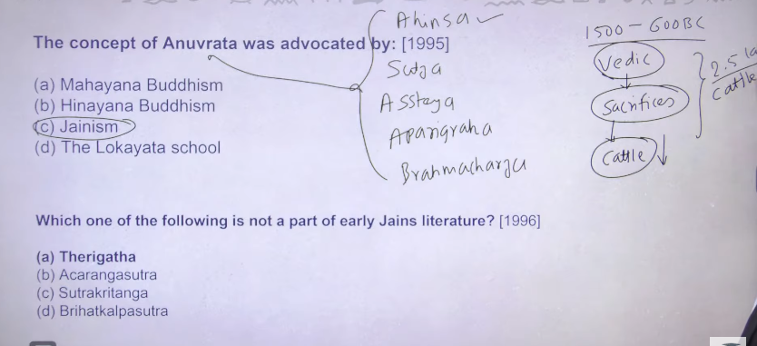

13